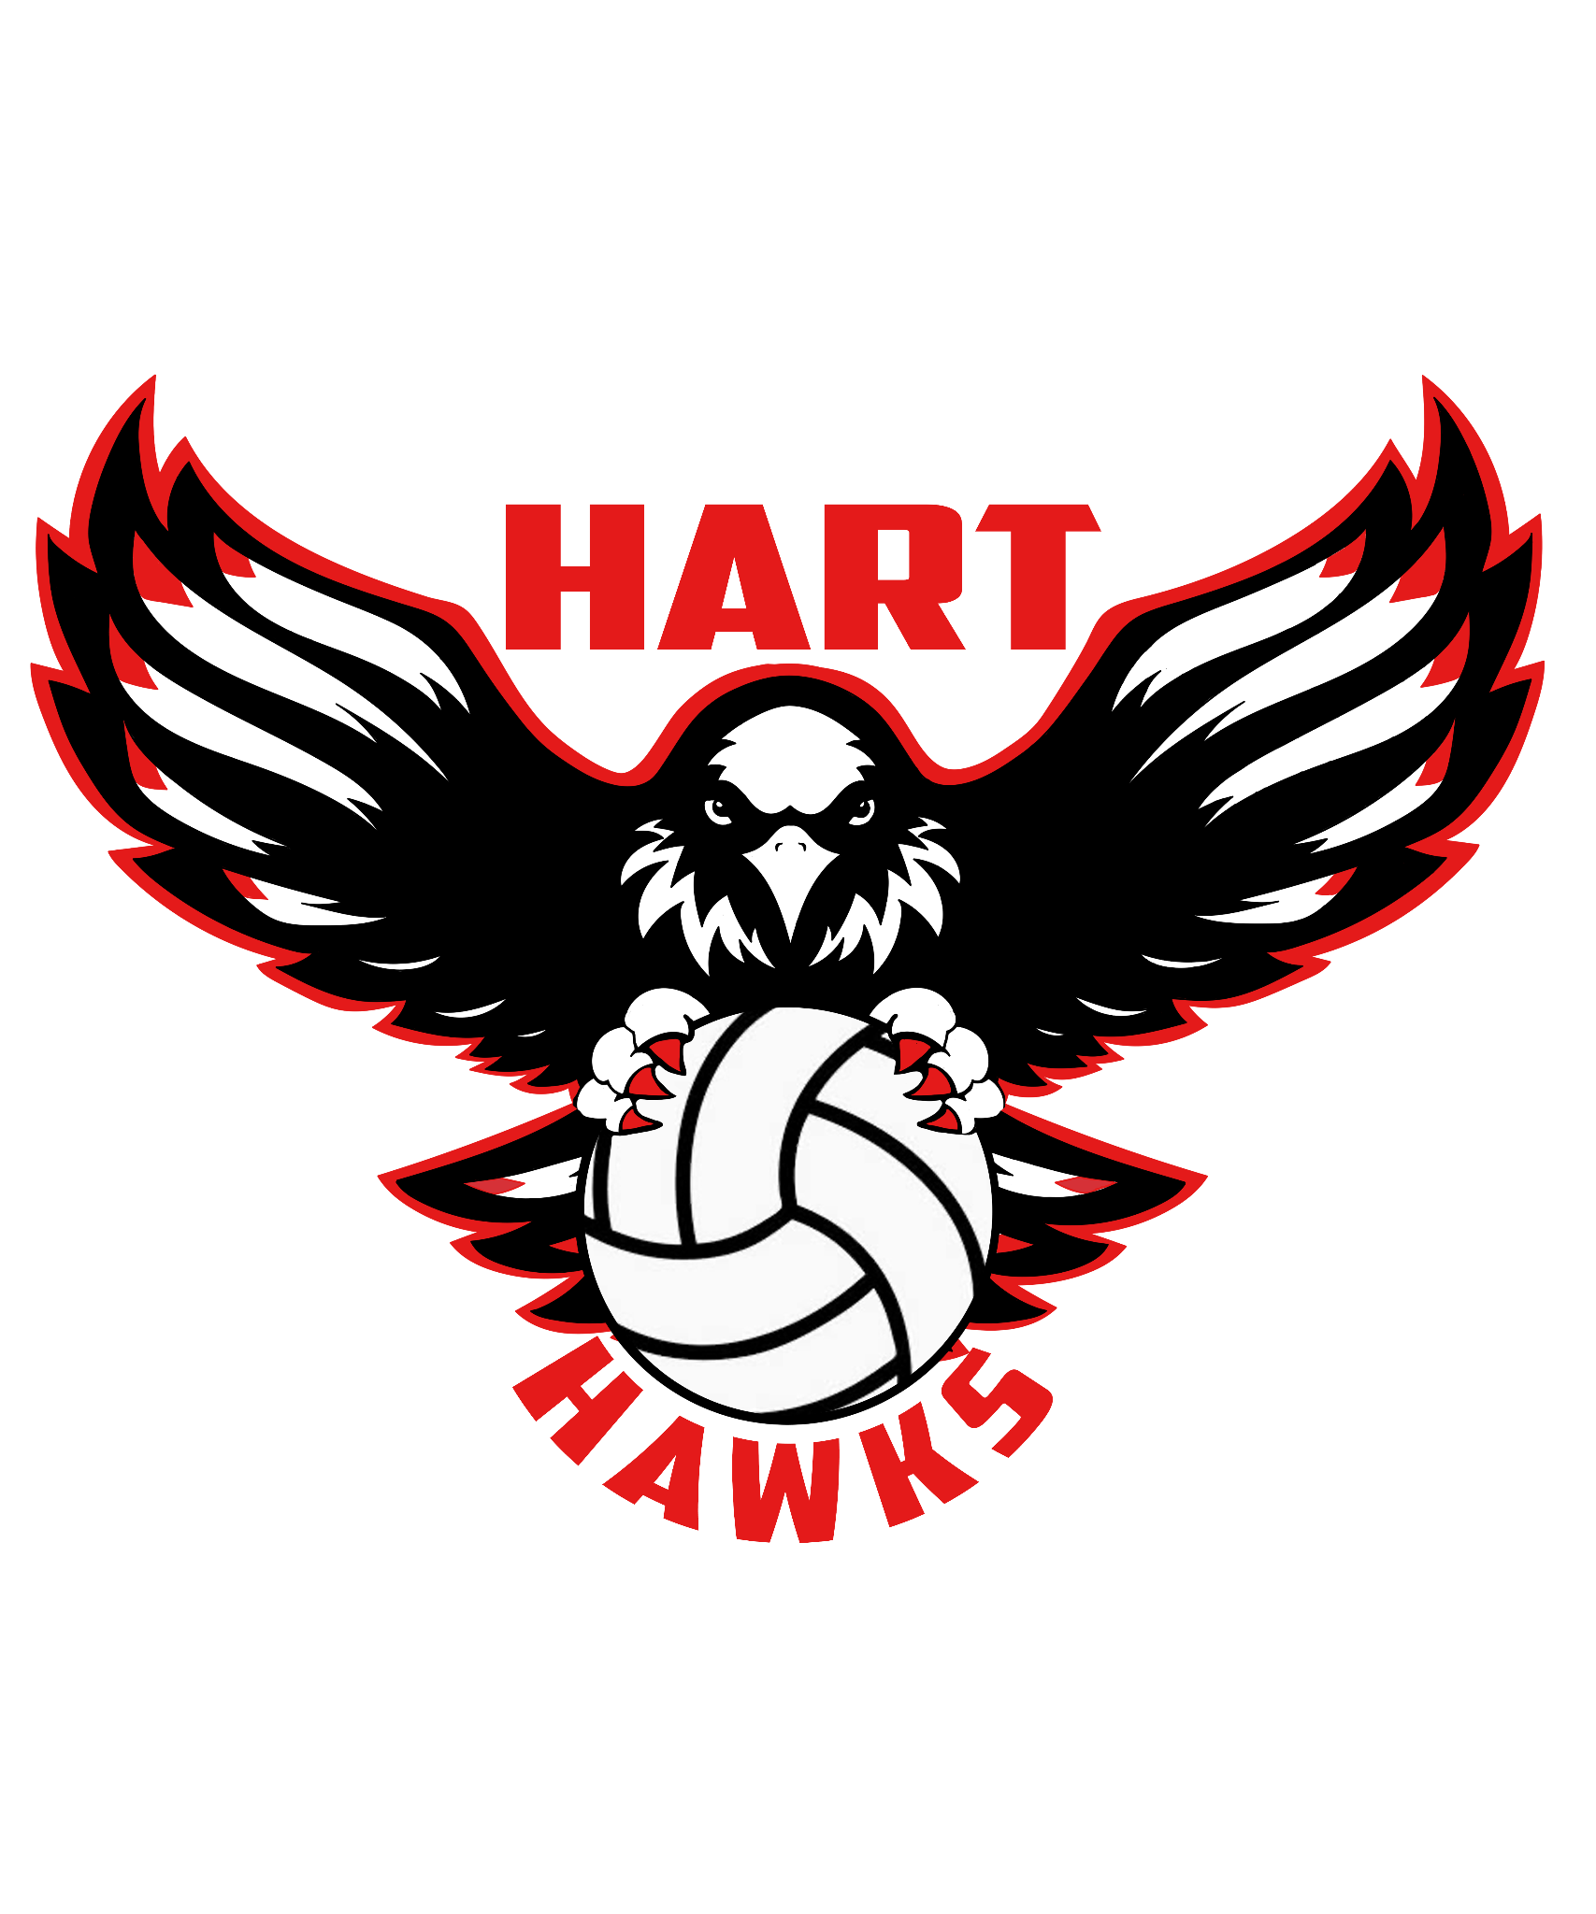

Hello,
The Hart High School Girls’ Volleyball team is currently looking for sponsors to support our team for the 2025 season.
Hart High has a long and distinguished history of outstanding achievement in sports. None of this would be possible without the support of our families, our classmates, and our valued sponsors, whose time, energy, and generosity give us the motivation and tools we need to give our best efforts on the court. School districts no longer have the resources to adequately fund these important athletic programs so we must turn to our friends and community businesses for their help.
I realize that many demands and requests are made for your financial support, and I appreciate your willingness to consider helping us make this season another successful one. Would you please take a moment to carefully consider helping our team financially to offset the costs of the upcoming season? Your contribution will be used to help our team in our quest for a Foothill League title. Without the help of such Sponsors, the financial burden on the families alone would be too much for some students to participate. With the contribution of Sponsor donations, we can allow everyone who makes the team play, regardless of their financial circumstances, to provide quality equipment and cover transportation and other costs for the players and coaches.
If you would like to participate as a Sponsor, we have a few options for your consideration:
1) Scoreboard Sponsorship $200.00 - Your business and logo will be on our revolving scoreboard and our game day program.
2) Major Donor $400.00 - Your business logo will be displayed on a pop-up banner at the entrance of the gym at every home game.
3) Canteen Sponsor $600.00 - At all home games, a banner will be prominently displayed on the front of the Canteen with all your business information. The Canteen allows the parents and kids from both schools to have food and beverages during all the games, Freshman, JV and Varsity.
In order to allow time for formatting and printing and have our banners displayed at the first game, we ask that you submit all information no later than August 1, 2025. Please send all information to the email address below.

Payment can be made by Check or by credit card through the QR code. If you have any questions, contact the head coach, Mary Irilian, at mirilian@hartdistrict.org. Checks can be made payable to: Hart Volleyball and given directly to the player to turn in, or mailed to: 24825 Newhall Ave. Santa Clarita, CA 91321.
Thank you for your kind consideration and support.
Hart Girls Volleyball Program
Tax ID number: 82-5488278

